DEPARTMENT OF MECHANICAL ENGINEERING
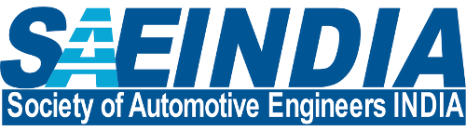
SOCIETY OF AUTOMOTIVE ENGINEERS INDIA
SAE Activities 2018-19

Sr. No. | Title of Activity / Workshop | Resource Person – Name, Designation & Organization | Date Conducted | Target Audience
1. | Design presentation in qualifying round of National event BAJA 2019. | SAE core technical team | 12/07/2018 and 13/06/2018 | Event judged by Technical Experts
2. | Participation in National event BAJA 2019 at Ropar, Punjab. | Entire SAE technical team | 08/03/2019 to 10/03/2019 | Event live on You Tube
3. | Participation in National event ESI 2018 at Pune. | Entire SAE technical team | 15/02/2018 to 19/02/2018 | Expert and other teams
 | Basic Automobile Workshop | SAE core team | 01/09/2018 | MGM School students
 | Design War on Solid Works model | SAE team members | 07/10/2018 | Students from SIESGT
 | Quiz on Automobile | SAE technical team | 08/10/2018 | Students from SIESGT

~ * ~ * ~

